**AFRL Research Collaboration Program**

**Contract FA8650-13-C-5800**

**Effect of Constituents and Microstructure on Energy Dissipation Mechanisms During Damage Growth**

**University: Texas A&M University**

**REPORT COVERS PERIOD: 3-1-17 THRU 6-30-17**

1. **PROJECT TEAM MEMBERS**
2. **LEAD UNIVERSITY POC:** John Whitcomb, 979-845-4006, jdw@tamu.edu
3. **PROJECT TEAM MEMBERS:** John Whitcomb, Collin Blake
4. **AFRL TECHNICAL POC:** Craig Przybyla
5. **TECHNICAL DISCUSSION**
6. **CURRENT WORK**Development of the infrastructure to perform mesoscale analysis of 3D textile composites.

**Background**

In the past couple of years, another graduate student, Scott McQuien, explored the accuracy of the VTMS suite of tools in predicting stresses in plain weave composites. Although Scott discovered a number of issues with the software, the geometry modeling capabilities were quite promising. Early in the last quarter, Keith Ballard, developed techniques to use the geometry calculated using VTMS and other modeling tools to develop a standard finite element model for a 3D textile composite. Based on Scott’s and Keith’s experience, we decided there was excellent potential for developing finite element models using the geometry engine. However, difficulties that Scott and Keith experienced convinced us that we needed to take a fresh look at the geometry creation component of VTMS and the subsequent finite element mesh generation. Accordingly, Collin spent the quarter continuing to learn VTMS for more complex model generations, as well as mesh generation techniques. Collin also began preparations for another visit to AFRL to work directly on VTMS. The following describes Collin’s activities during the quarter. I should point out that Keith Ballard is not supported by this contract, but does provide mentoring for Keith. Scott McQuien was supported last summer as an intern at AFRL, during which time he helped identify some errors in the VTMS coding.

**Approach**

Collin learned the basic process that VTMS uses to generate its geometries last quarter. The results of this process are shown in Figure 1.

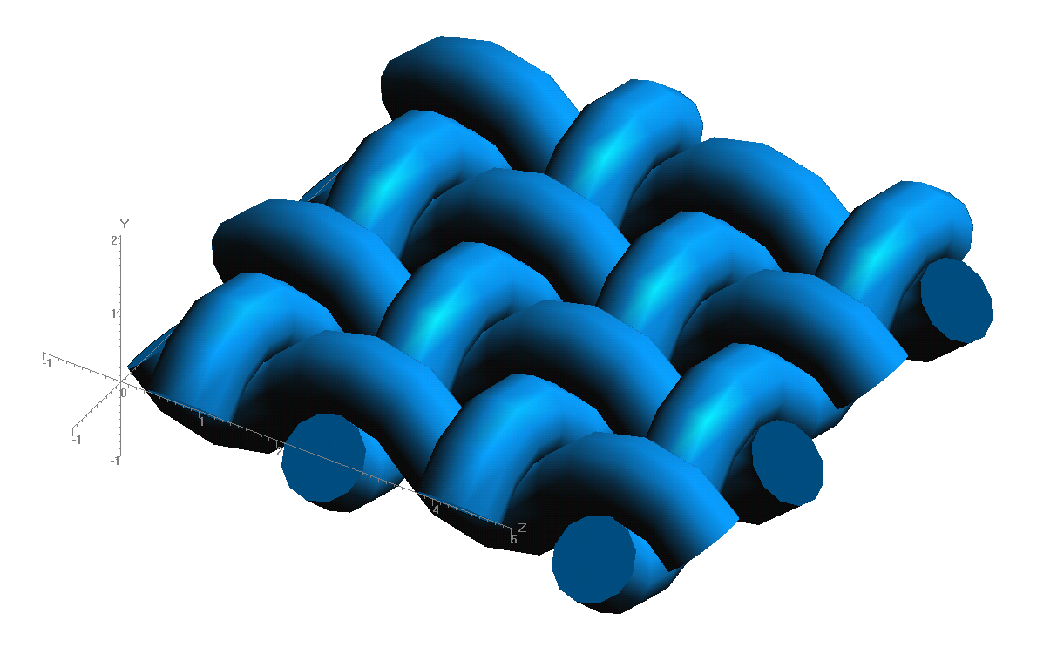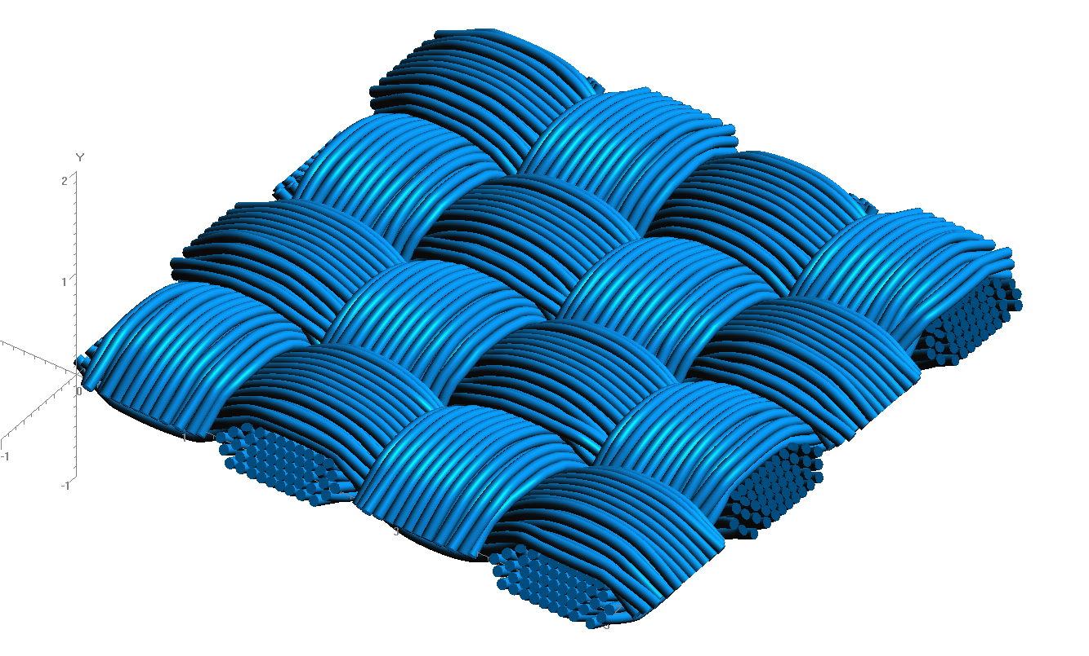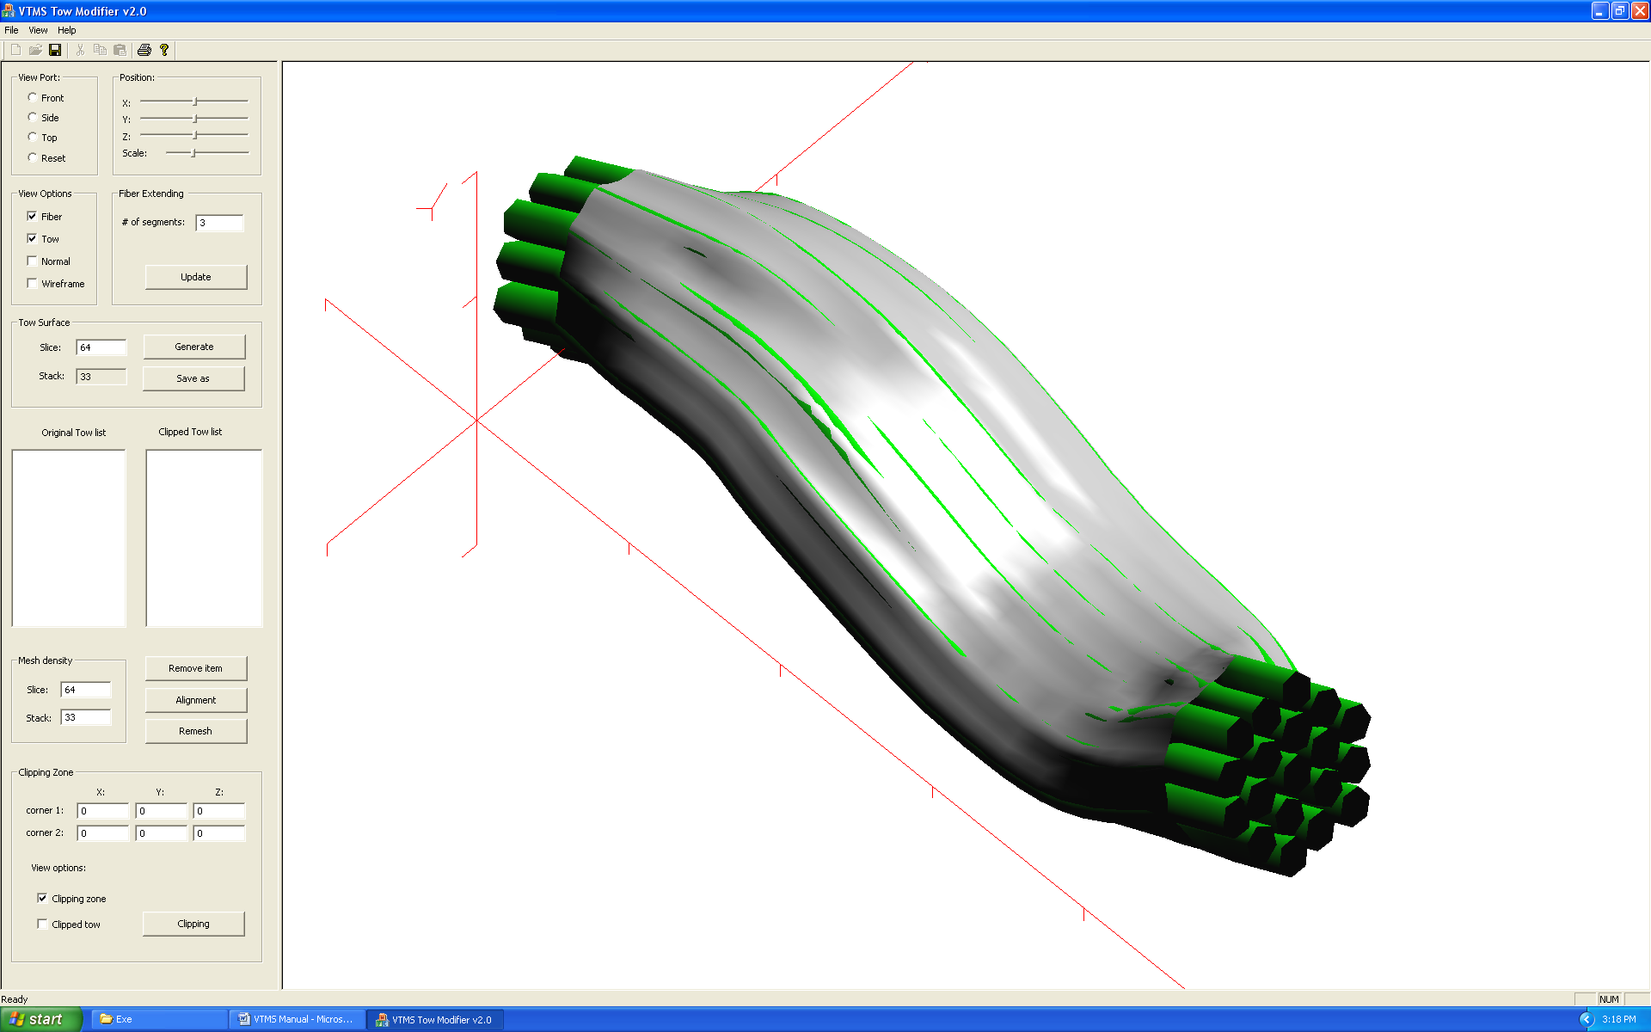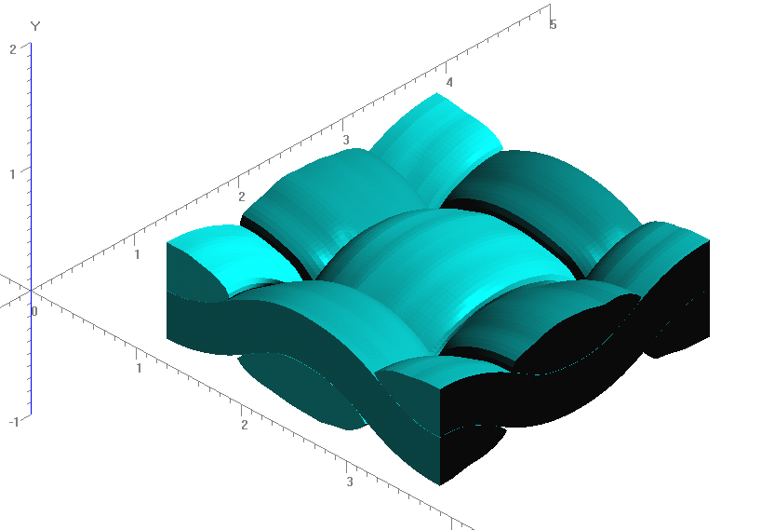

**Figure 1: Evolution of Weave Tow Geometry**

This quarter Collin learned the finer details of producing this geometry and learned how to produce more complex geometries and weave patterns. Also, a look at a similar program called DFMA, developed at Kansas State University, was taken to analyze its process. We wanted to compare the initialization of both processes to gain more insight into the method of Digital Chain elements that creates the geometry. This allowed for a better understanding of how certain input parameters were being applied to VTMS to allow for better success in creating the complex geometries we hoped to create. One result of a complex geometry can be seen in Figure 2.

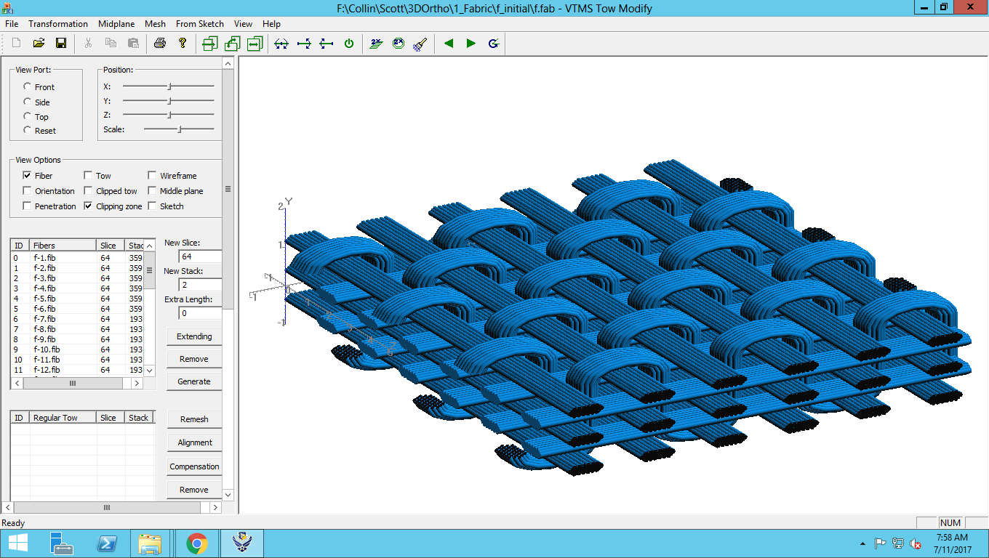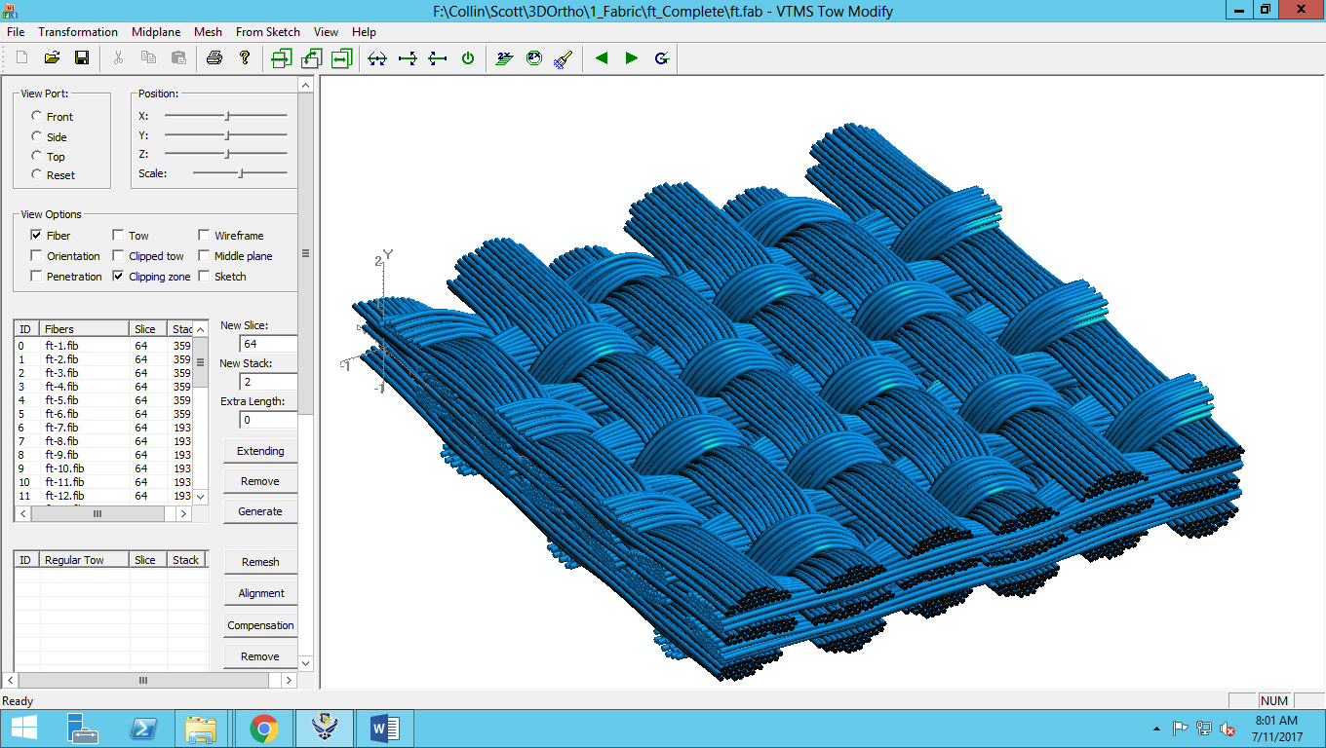

**Figure 2: Preliminary-to-Post Relaxation of Complex Fabric Geometry**

A better understanding of producing models in VTMS was required for both creating models for analysis as well as a precursor to Collin working at AFRL this summer. His goal during the summer will be to improve certain aspects of the software to better suit our research needs. These improvements will be specifically towards tow penetration improvements and compatible meshing techniques. This will aid in reducing the amount of work to get models from VTMS to analysis for many users of the software including our group.

We also continued pursuing meshing software to aid in meshing these complex geometries. As NetGen was the most promising candidate, Collin continued to work on using its routines at the beginning of the quarter to implement into our own mesh generation software. The next step in fully implementing NetGen is to allow the software to accept our preferred geometry files so that we can use it for our purposes.

1. **CONCLUSIONS/ANALYSIS TO DATE**

The creation of realistic, non-idealized tow geometry is possible with the VTMS software. Further improvements to VTMS can be made to make it more compatible for traditional FEA like our group is using. Once these improvements are made, we will return to meshing these improved models and implementing routines to help this process.

1. **WORK FORECAST AND PLANS**Collin Blake is at AFRL as an intern this summer. His focus is to understand the details of the geometry generation engine in VTMS. The goal is to identify the parts of the code that are causing major problems and to attempt to remedy these issues. Since the code was developed by a highly skilled analyst (Eric Zhou), it is recognized that this will be very challenging. The strategy is to collaborate with Eric and hopefully, by taking a fresh look at the algorithms, solutions can be developed.